# HW9 Writeup

# Pritesh Patel

## Intro

I ran my distributed training on 2 P100 based VMs. And so it took a very long time. In the end I had to stop the training at around 30,000 steps. I did begin to see the curves expected in BLEU score, eval_loss and learning rate.

## Answers

1. The training took over 2 days (about 50 hours to get to 32000 steps)
2. I don’t think the model is fully trained I still see improvements in loss scores
3. I don’t think I was overfitting quite yet
4. The GPUs were fully utilized at times and then not so. Here is a screenshot

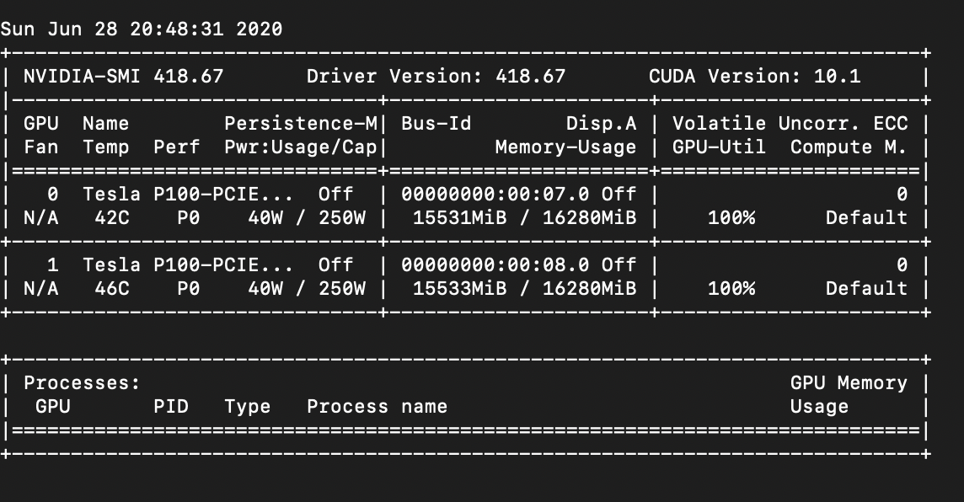

This was quite often the case but there were times when it would drop to 0%

1. I ran nmon, here is a screenshot:

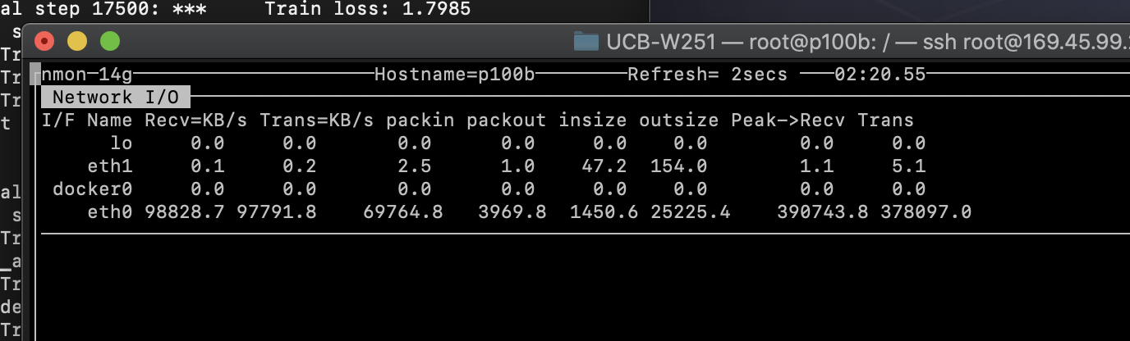

I don’t think the network was a bottleneck at all times but network utilization was quite high at times. I suspect the GPU and network were getting pushed dependent on whether the model was calculating or distributing weights.

1. I think the spike at the beginning represents the warmup steps. You can notice on the graph that at 8000 steps the learning rate begins to drop.
2. The training set was 636MB English phrases and 710MB German phrases. Looks like it had 4562102 lines.
3. Looks like a model data file, an index and a metadata file.
4. The checkpoint is 730MB
5. Overall each step took approx. 32000/50hrs = 0.2 secs . Although when tailing the nohup output it was claiming that each step took 5.5 milliseconds
6. I think that the network time is not counted in the nohup output. I assume that a majority of time was spent redistributing the weights.

Here are the plots:

